What is t-SNE?
t-Distributed Stochastic Neighbor Embedding (t-SNE) is an unsupervised, non-linear technique primarily used for data exploration and visualizing high-dimensional data. In simpler terms, t-SNE gives you a feel or intuition of how the data is arranged in a high-dimensional space. It was developed by Laurens van der Maatens and Geoffrey Hinton in 2008.
What is Dimensionality Reduction?
Dimensionality Reduction is the technique of representing n-dimensions data(multidimensional data with many features) in 2 or 3 dimensions.
An example of dimensionality reduction can be discussed as a classification problem i.e. student will play football or not that relies on both temperature and humidity can be collapsed into just one underlying feature, since both of the features are correlated to a high degree. Hence, we can reduce the number of features in such problems. A 3-D classification problem can be hard to visualize, whereas a 2-D one can be mapped to simple 2-dimensional space and a 1-D problem to a simple line.

How does t-SNE works?
t-SNE a non-linear dimensionality reduction algorithm finds patterns in the data based on the similarity of data points with features, the similarity of points is calculated as the conditional probability that a point A would choose point B as its neighbour.
It then tries to minimize the difference between these conditional probabilities (or similarities) in higher-dimensional and lower-dimensional space for a perfect representation of data points in lower-dimensional space.

How t-SNE works

- The t-SNE algorithm calculates a similarity measure between pairs of instances in the high dimensional space and in the low dimensional space. It then tries to optimize these two similarity measures using a cost function.
- Step 1, measure similarities between points in the high dimensional space. Think of a bunch of data points scattered on a 2D space. For each data point (xi) we’ll center a Gaussian distribution over that point. Then we measure the density of all points (xj) under that Gaussian distribution. Then renormalize for all points. This gives us a set of probabilities (Pij) for all points. Those probabilities are proportional to the similarities. All that means is, if data points x1 and x2 have equal values under this gaussian circle then their proportions and similarities are equal and hence you have local similarities in the structure of this high-dimensional space.
- 2. Step 2 is similar to step 1, but instead of using a Gaussian distribution you use a Student t-distribution with one degree of freedom, which is also known as the Cauchy distribution.

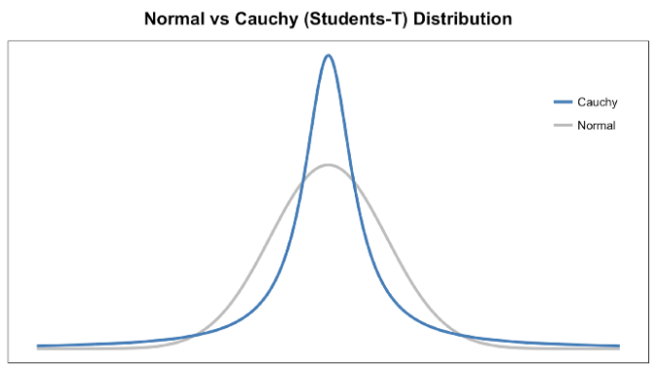

3. The last step is that we want these set of probabilities from the low-dimensional space (Qij) to reflect those of the high dimensional space (Pij) as best as possible. We want the two map structures to be similar. We measure the difference between the probability distributions of the two-dimensional spaces using Kullback-Liebler divergence (KL). I won’t get too much into KL except that it is an asymmetrical approach that efficiently compares large Pij and Qij values. Finally, we use gradient descent to minimize our KL cost function.

